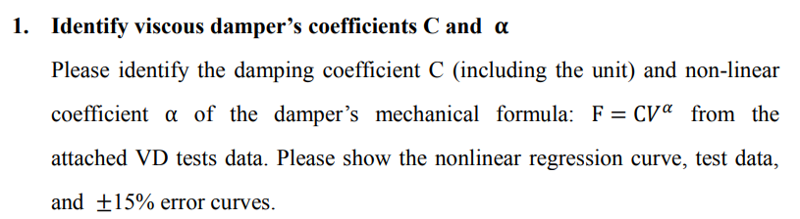

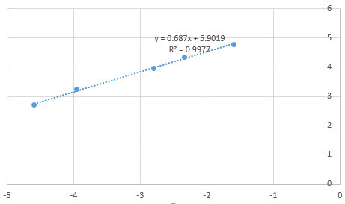



clc; clear; close all;

filename = 'VD tests(revised).xlsx';

sheet = 1;

disp005 = xlsread(filename, sheet, 'B3:B3739');

force005 = xlsread(filename, sheet, 'C3:C3739');

disp01 = xlsread(filename, sheet, 'E3:E3957');

force01 = xlsread(filename, sheet, 'F3:F3957');

disp03 = xlsread(filename, sheet, 'H3:H3773');

force03 = xlsread(filename, sheet, 'I3:I3773');

disp05 = xlsread(filename, sheet, 'K3:K4002');

force05 = xlsread(filename, sheet, 'L3:L4002');

disp1 = xlsread(filename, sheet, 'N3:N3759');

force1 = xlsread(filename, sheet, 'O3:O3759');

x = [dis(disp005, 0.05) dis(disp01, 0.1) dis(disp03, 0.3) dis(disp05, 0.5) dis(disp1, 1)].';

y = [force(force005) force(force01) force(force03) force(force05) force(force1)].';

alpha_ = 0.687;

lnC = 5.9019;

vel = 0 : 0.0001 : 0.25;

f = exp(5.9019) * vel .^ 0.687;

figure;

theory = plot(vel, f, 'k');

hold on;

test_data = plot(x, y, 'r*');

hold on;

error_range = plot(vel, 1.15 * f, 'r:', vel, 0.85 * f, 'r:');

title('');

xlabel('Velocity (mm/sec)');

ylabel('Force (tf)');

legend([theory, test_data, error_range(1)], '理論值', '試驗值', '15%誤差範圍', 'Location', 'southeast');

function *output* = dis(*input*, *f*)

output = max(abs(diff(input) * f));

end

function *output* = force(*input*)

output = max(abs(input));

end

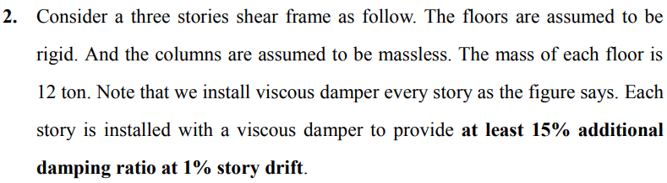

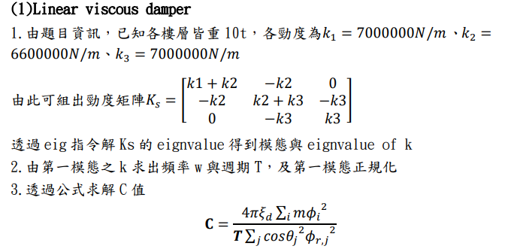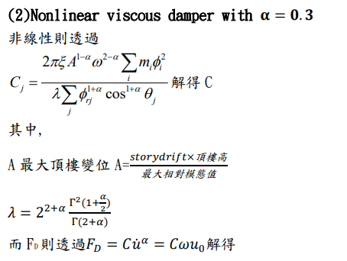

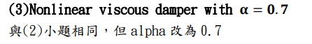



clc; clear; close all;

m = 12;

k1 = 7e3;

k2 = 6.6e3;

k3 = 7e3;

ks = [

k1 + k2, -k2, 0;

-k2, k2 + k3, -k3;

0, -k3, k3;

];

[modeshape, eig_k] = eig(ks);

omega = sqrt(eig_k(1, 1) / m);

period = 2 * pi / omega;

modeshape_normailzed = modeshape(:, 1) / modeshape(3, 1);

xi_d = 0.15;

cos_theta = 4 / 5;

next_reduce_prev = [

1, 0, 0;

-1, 1, 0;

0, -1, 1;

];

relative_modeshape = next_reduce_prev * modeshape_normailzed;

c_linear = 4 * pi * xi_d * m * sum(modeshape_normailzed .^ 2) / (period * (cos_theta ^ 2) * sum(relative_modeshape .^ 2))

*% 302*

story_drift = 0.01;

h = 3;

u0 = story_drift * h * cos_theta;

*% linear*

FD_linear = c_linear * u0 * omega

*% 77*

*% =========================*

*% nonlinear*

alpha_ = 0.3;

A = story_drift * h / max(relative_modeshape);

lamda = 2 ^ (2 + alpha_) * gamma(1 + alpha_ / 2) ^ 2 / gamma(2 + alpha_);

c_nonlinear = 2 * pi * xi_d * A ^ (1 - alpha_) * omega ^ (2 - alpha_) * sum(m * (modeshape_normailzed .^ 2)) / (lamda * sum(relative_modeshape .^ (1 + alpha_) * cos_theta ^ (1 + alpha_)))

*% 88*

FD_nonlinear = c_nonlinear * (omega * u0) ^ alpha_

*% 58*

*% =========================*

*% nonlinear*

alpha_ = 0.7;

A = story_drift * h / max(relative_modeshape);

lamda = 2 ^ (2 + alpha_) * gamma(1 + alpha_ / 2) ^ 2 / gamma(2 + alpha_);

c_nonlinear = 2 * pi * xi_d * A ^ (1 - alpha_) * omega ^ (2 - alpha_) * sum(m * (modeshape_normailzed .^ 2)) / (lamda * sum(relative_modeshape .^ (1 + alpha_) * cos_theta ^ (1 + alpha_)))

*% 180*

FD_nonlinear = c_nonlinear * (omega * u0) ^ alpha_

*% 69*

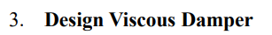



**Since viscous damper don’t provide stiffness, periods have no change.**

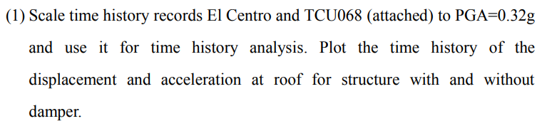

**Linear viscous damper**



**Nonlinear viscous damper with $α=0.3$**

     

**Nonlinear viscous damper with**

     

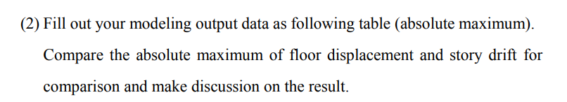

**Linear viscous damper**



**Nonlinear viscous damper with $α=0.3$**



**Nonlinear viscous damper with $α=0.7$**



Discuss

1. VD VE 皆可以降低很多結構物的反應
2. TCU068 EW 向 加速度的效果比較不穩定
3. 從 ratio responses 來看，會發現 linear 與 nonlinear 的效果差別不大
4. 但從 story drift 來看會發現 $nonlinear α=0.3>nonlinear α=0.7>linear$

clc; clear; close all;

generate_max('El_Centro_ALL')

generate_max('TCU068_EW_ALL')

generate_max('TCU068_NS_ALL')

function [] = generate_max(*filename*)

A_2F = filename_to_array(filename, 10, 2, 17) * 100;

V_2F = filename_to_array(filename, 10, 3, 17) * 100;

D_2F = filename_to_array(filename, 10, 4, 17) * 100;

A_3F = filename_to_array(filename, 10, 5, 17) * 100;

V_3F = filename_to_array(filename, 10, 6, 17) * 100;

D_3F = filename_to_array(filename, 10, 7, 17) * 100;

A_RF = filename_to_array(filename, 10, 8, 17) * 100;

V_RF = filename_to_array(filename, 10, 9, 17) * 100;

D_RF = filename_to_array(filename, 10, 10, 17) * 100;

A_2F_nodamper = filename_to_array((filename + "_nodamper"), 10, 2, 17) * 100;

V_2F_nodamper = filename_to_array((filename + "_nodamper"), 10, 3, 17) * 100;

D_2F_nodamper = filename_to_array((filename + "_nodamper"), 10, 4, 17) * 100;

A_3F_nodamper = filename_to_array((filename + "_nodamper"), 10, 5, 17) * 100;

V_3F_nodamper = filename_to_array((filename + "_nodamper"), 10, 6, 17) * 100;

D_3F_nodamper = filename_to_array((filename + "_nodamper"), 10, 7, 17) * 100;

A_RF_nodamper = filename_to_array((filename + "_nodamper"), 10, 8, 17) * 100;

V_RF_nodamper = filename_to_array((filename + "_nodamper"), 10, 9, 17) * 100;

D_RF_nodamper = filename_to_array((filename + "_nodamper"), 10, 10, 17) * 100;

fprintf('%.3f %.3f %.3f %d %.3f %.3f %.3f %d %.3f %.3f %.3f\n', max(D_RF_nodamper), max(V_RF_nodamper), max(A_RF_nodamper), 1, max(D_RF), max(V_RF), max(A_RF), 1, max(D_RF) / max(D_RF_nodamper), max(V_RF) / max(V_RF_nodamper), max(A_RF) / max(A_RF_nodamper));

fprintf('%.3f %.3f %.3f %d %.3f %.3f %.3f %d %.3f %.3f %.3f\n', max(D_3F_nodamper), max(V_3F_nodamper), max(A_3F_nodamper), 1, max(D_3F), max(V_3F), max(A_3F), 1, max(D_3F) / max(D_3F_nodamper), max(V_3F) / max(V_3F_nodamper), max(A_3F) / max(A_3F_nodamper));

fprintf('%.3f %.3f %.3f %d %.3f %.3f %.3f %d %.3f %.3f %.3f\n', max(D_2F_nodamper), max(V_2F_nodamper), max(A_2F_nodamper), 1, max(D_2F), max(V_2F), max(A_2F), 1, max(D_2F) / max(D_2F_nodamper), max(V_2F) / max(V_2F_nodamper), max(A_2F) / max(A_2F_nodamper));

end

clc; clear; close all;

plot_timehistory('El_Centro_RF', 'El Centro')

plot_timehistory('TCU068_EW_RF', 'TCU068 EW')

plot_timehistory('TCU068_NS_RF', 'TCU068 NS')

function [] = plot_timehistory(*filename*, *titlename*)

period = filename_to_array(filename, 3, 1, 10);

acceleration = filename_to_array(filename, 3, 2, 10);

displacement = filename_to_array(filename, 3, 3, 10);

acceleration_nodamper = filename_to_array((filename + "_nodamper"), 3, 2, 10);

displacement_nodamper = filename_to_array((filename + "_nodamper"), 3, 3, 10);

figure;

plot(period, acceleration_nodamper, period, acceleration);

title([titlename ' Roof absolute acceleration']);

xlabel('Time(sec)');

ylabel('acceleration(m/s^2)');

legend({'without damper', 'with damper'}, 'Location', 'northeast');

figure;

plot(period, displacement_nodamper, period, displacement);

title([titlename ' Roof relative displacement']);

xlabel('Time(sec)');

ylabel('displacement(m)');

legend({'without damper', 'with damper'}, 'Location', 'northeast');

end

clc; clear; close all;

m = [1.21129 1.20846 0.96506].';

period = 0.3290;

omega = 2 * pi / period;

modeshape = [0.2683 0.5520 0.7489].';

modeshape_normailzed = modeshape(:, 1) / modeshape(3, 1);

xi_d = 0.18;

cos_theta = [(2.25 / 3) / sqrt((2.25 / 3) ^ 2 + 1.5 ^ 2), (2.25 / 3) / sqrt((2.25 / 3) ^ 2 + 1.25 ^ 2), (2.25 / 3) / sqrt((2.25 / 3) ^ 2 + 1.25 ^ 2)].';

next_reduce_prev = [

1, 0, 0;

-1, 1, 0;

0, -1, 1;

];

relative_modeshape = next_reduce_prev * modeshape_normailzed;

c_linear = 4 * pi * xi_d * sum(m .* modeshape_normailzed .^ 2) / (period * sum((cos_theta .^ 2) .* (relative_modeshape .^ 2)))

*% 149*

story_drift = 0.01;

h = 1.5;

u0 = story_drift * h * cos_theta;

*% linear*

*% FD_linear = c_linear * u0 * omega*

*% =========================*

*% nonlinear*

alpha_ = 0.3;

A = story_drift * h / max(relative_modeshape);

lamda = 2 ^ (2 + alpha_) * gamma(1 + alpha_ / 2) ^ 2 / gamma(2 + alpha_);

c_nonlinear = 2 * pi * xi_d * A ^ (1 - alpha_) * omega ^ (2 - alpha_) * sum((m .* modeshape_normailzed .^ 2)) / (lamda * sum(relative_modeshape .^ (1 + alpha_) .* cos_theta .^ (1 + alpha_)))

*% 49*

*% FD_nonlinear = c_nonlinear * (omega * u0) ^ alpha_*

*% =========================*

*% nonlinear*

alpha_ = 0.7;

A = story_drift * h / max(relative_modeshape);

lamda = 2 ^ (2 + alpha_) * gamma(1 + alpha_ / 2) ^ 2 / gamma(2 + alpha_);

c_nonlinear = 2 * pi * xi_d * A ^ (1 - alpha_) * omega ^ (2 - alpha_) * sum((m .* modeshape_normailzed .^ 2)) / (lamda * sum(relative_modeshape .^ (1 + alpha_) .* cos_theta .^ (1 + alpha_)))

*% 93*

*% FD_nonlinear = c_nonlinear * (omega * u0) ^ alpha_*

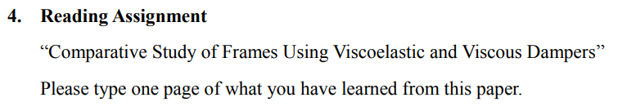

Viscoelastic 和 Viscous damper 都會對系統多加勁度和阻尼。在長週期低頻率下，viscoelastic damper 增加阻尼和勁度，而 viscous damper 主要增加阻尼。對於 harmonic excitation，damper 可以有效降低位移反應，所以可以降低桿件內力。但是對於 impulse excitation，勁度對於位移反應的影響比阻尼還大。如果VE 和 VS 提供相同的 damping ratio，他們對於柱軸力有相同的效果。對於能量消散，VS 比 VE 好一點點，這是因為 VS 可以變形更大。但不論是用甚麼阻尼，他們對於地震力和變形都有很好的效果。為了達到最佳化的效果，斜撐的勁度要是構架勁度的 10 倍。在週期為 0.5-2.5秒時，paper對於結構物反應有非常不錯的預測，而且他還可以更好的改進，像是減少阻尼，調整週期等。